Name | Ndongla Roy Longpi
Department | Computer networking and cybersecurity
task | SQL injection

SQL injection exploitation
SQL injection is a cybersecurity vulnerability which occurs when, user input is been concatenated directly into the SQL query instead of being passed as a parameter.
Which is been carried out by inject SQL syntax into the input and change the meaning of the query.
SQL injection is been carried out against a vulnerable application such as DVWA in the following steps.
In this case I will be using Kali Linux for accessing my vulnerable application by entering a series of command.
Building a local lab using DVWA (damn vulnerable web application) on kali linux.
Under kali Linux a series of command are been entered in order to build the local lab, these commands include.
- Setting up an SQL injection lab which includes entering commands for installing Apache, MariaDB and PHP
After entering the commands, it showed active and running indicating that Apache, MariaDB and PHP has been installed
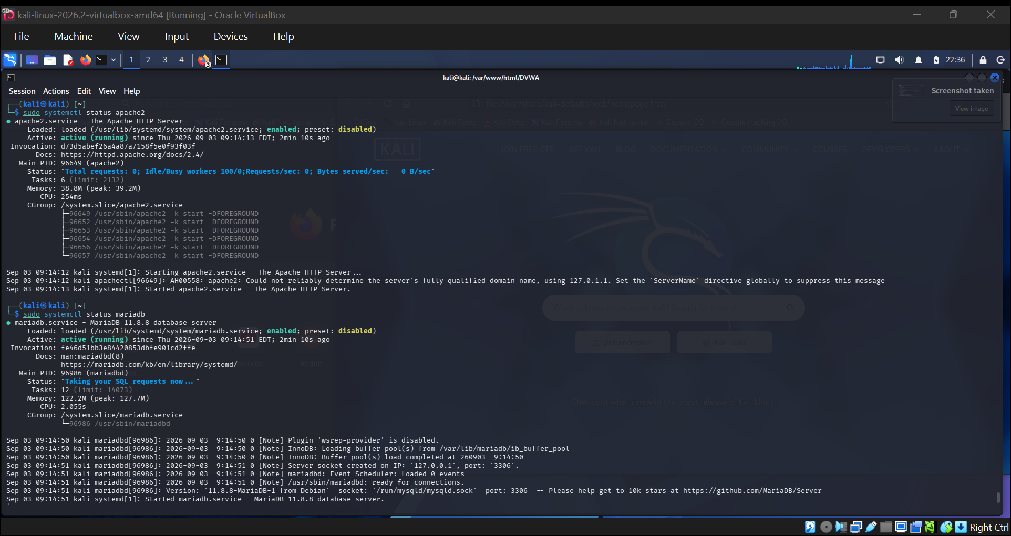
- After succeeding on creating a SQL injection lab, I then proceeded to installing DVWA by passing a series of commands to kali Linux.
After entering the command it gave DVWA and a certain text which was an indication that DVWA installation has been completed.

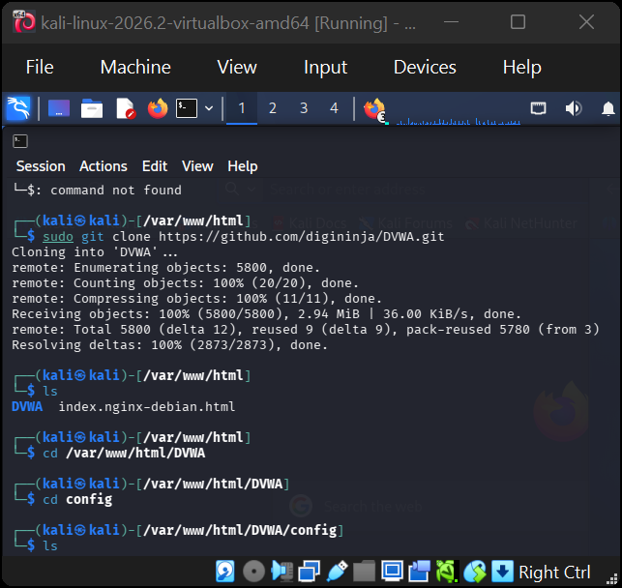

- The next step after downloading DVWA was to configure the database setting of DVWA which after configuration you are going to obtain config.inc.php.dist together with a data base section.

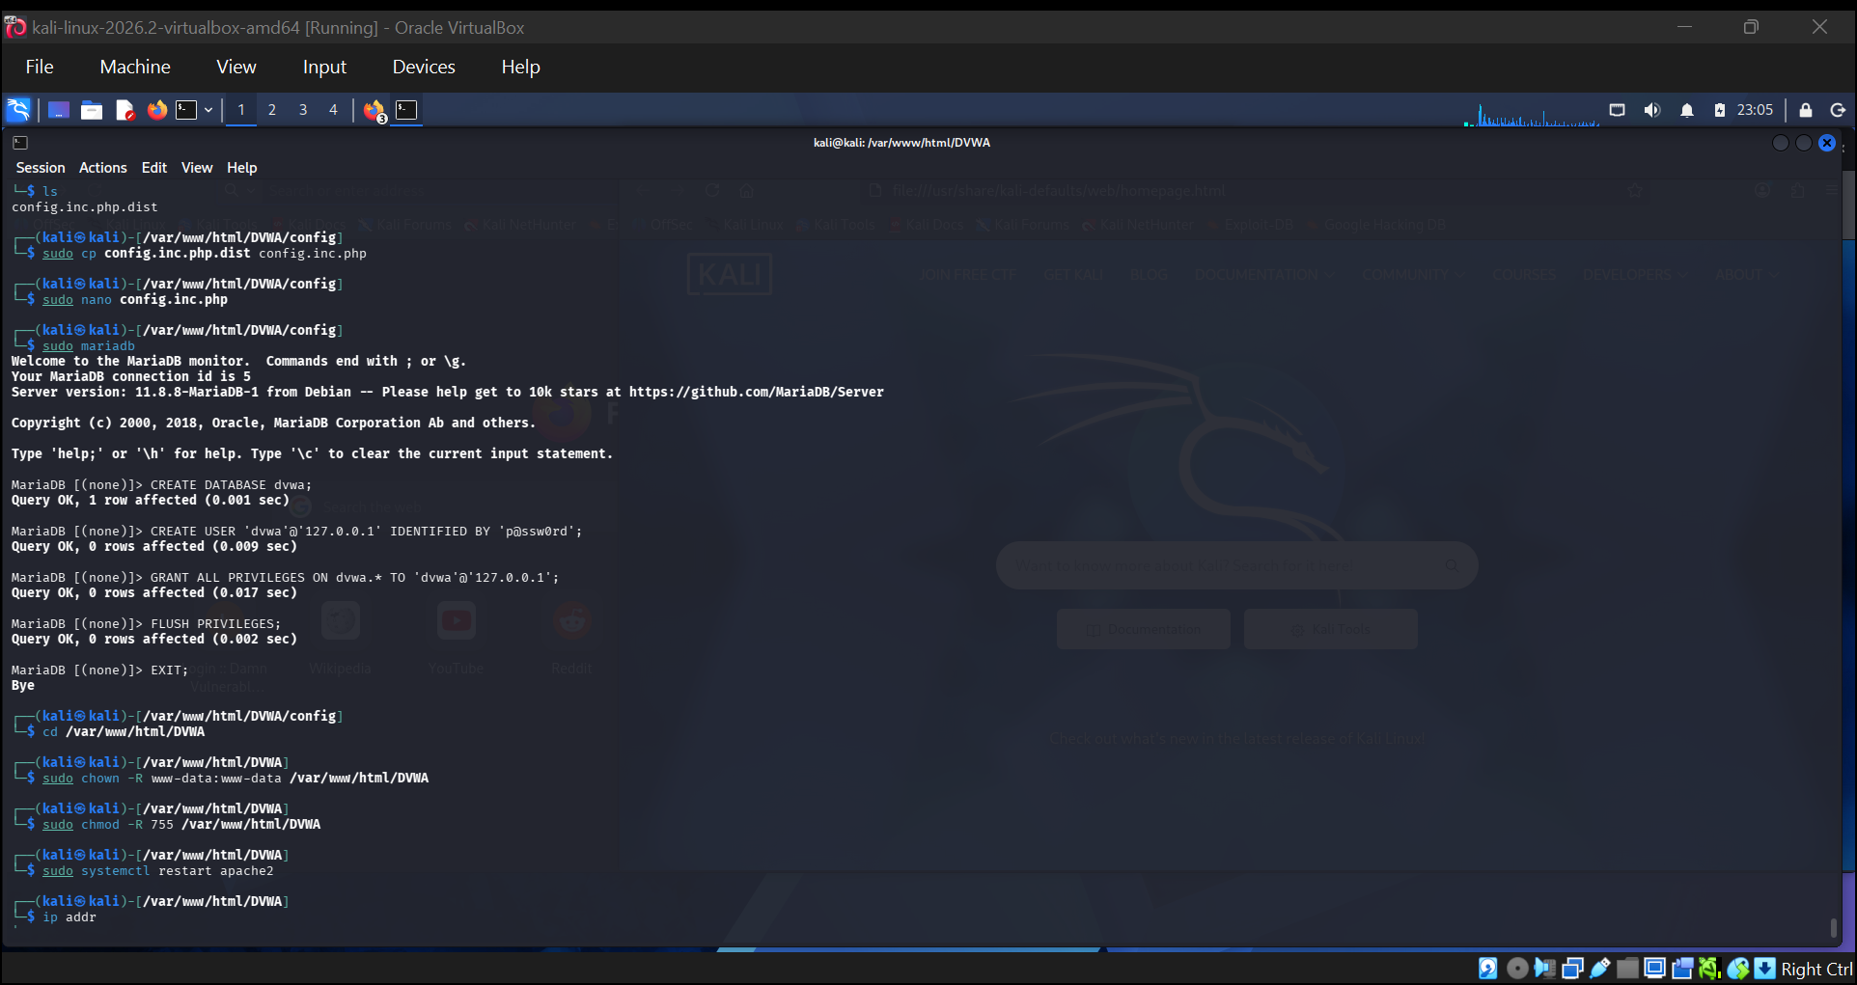

- After successfully configuring DVWA, I then move on to creating a database which is to manipulated and permission is also been fixed which enables us to access DVWA over the website fire fox were SQL injection will be carried out.
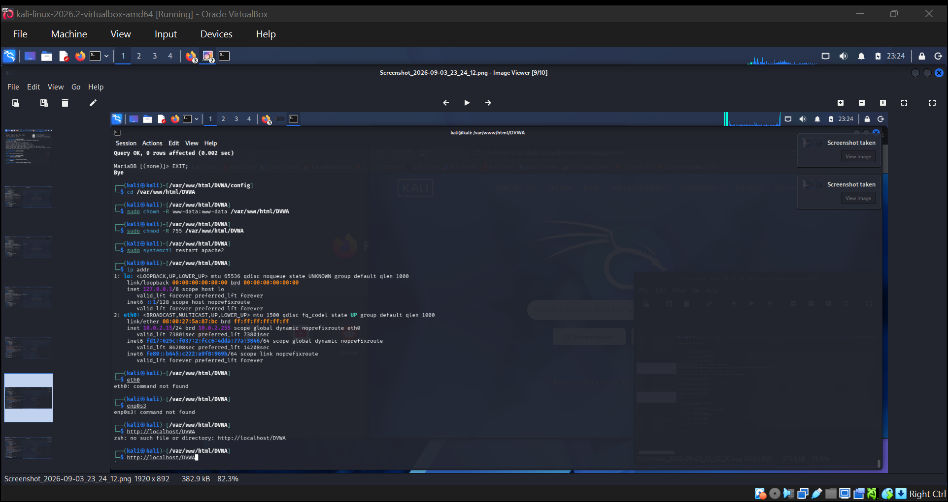

After successfully creating a local lab with DVWA, with the help of the link and permission I could know get access to my vulnerable web application were I could practice SQL injection which includes.
- SQL login bypass
After opening the vulnerable web application I login by entering the default username and password which grant me access to the web application.

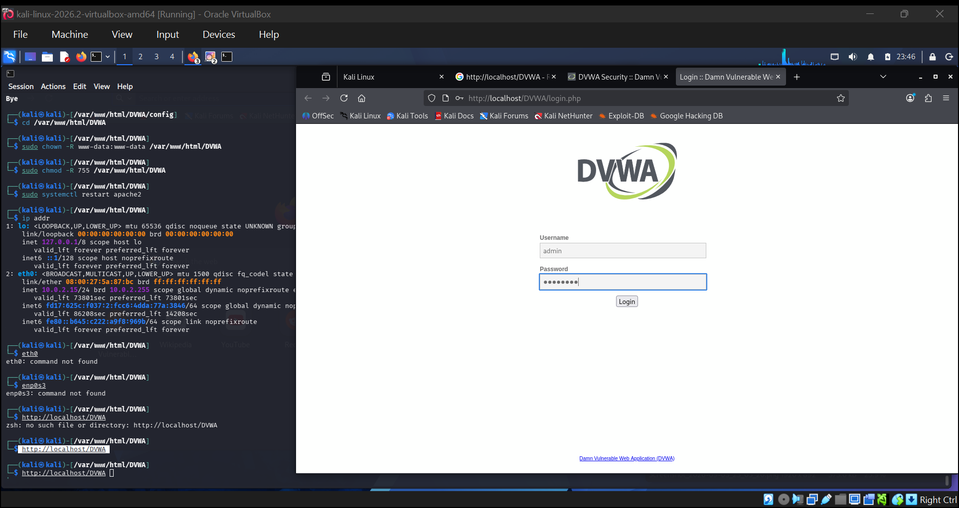
- Extracting data from data base using sql injection.
Under the DVWA deliberately vulnerable website, I extracted data from the data base by going to SQL injection were I could access the data base, from which I was capable of extracting data.
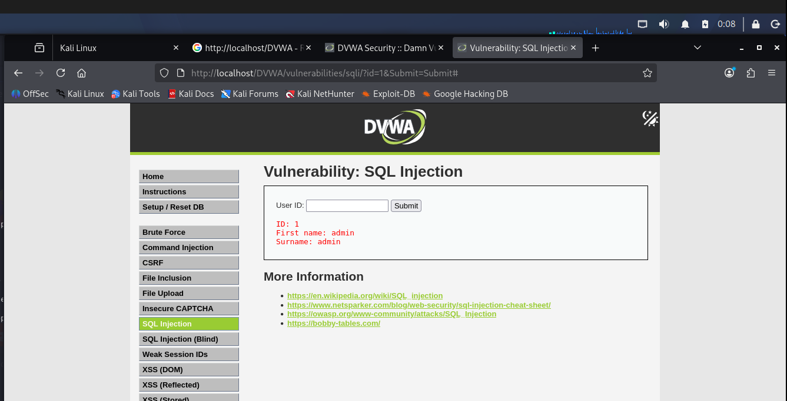

With the help of union select I was capable of extracting several column from the data base.
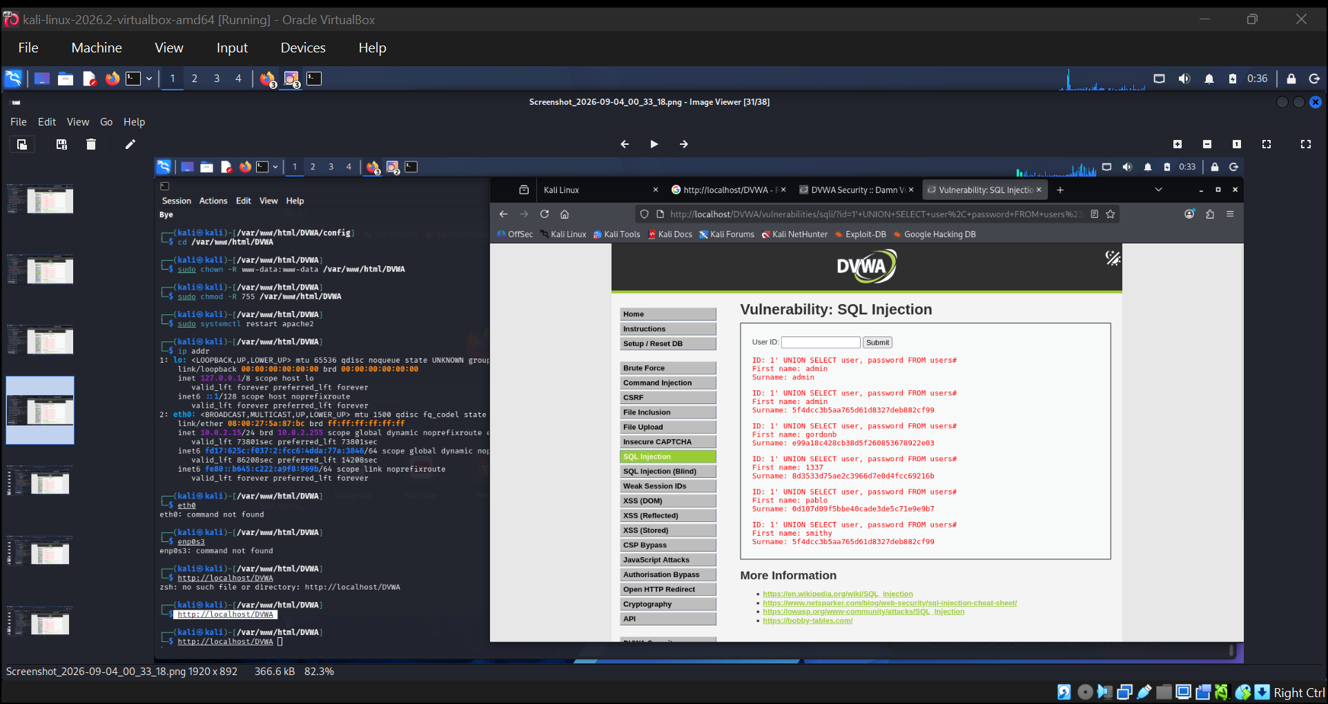

- Data modification.
Under the vulnerable web application I modified it security level from impossible low, by going to DVWA security and choosing low,

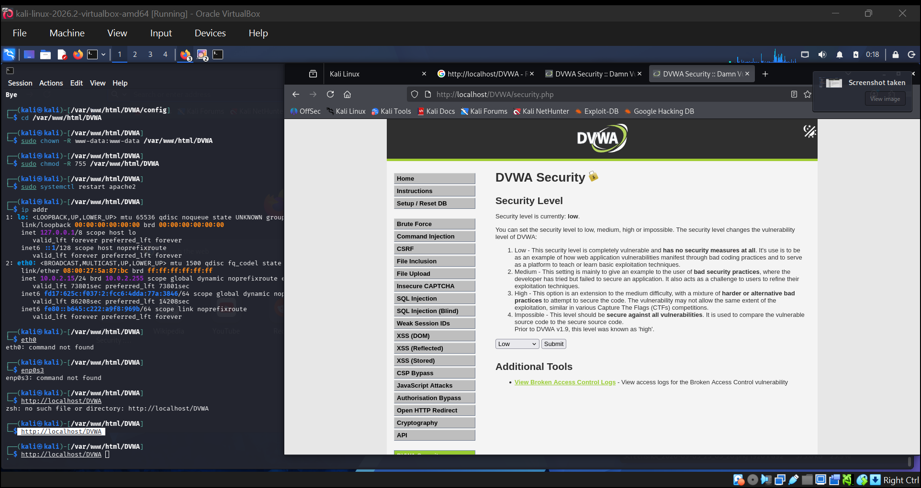

Preventive measures against SQL injection
Preventive measures which protect web applications against SQL injection includes
- Use parameterized queries (prepared statements) – Keep SQL commands separate from user input.
- Validate user input – Accept only data that matches the expected forma
- Use stored procedures carefully – Avoid dynamically constructing SQL inside them.
- Apply least privilege – Give the database account only the permissions it actually needs.
- Avoid displaying detailed database errors – Error messages can reveal database structure to attackers.

